Reachdesk Order fulfilment

Contents

- Email Alert
- Login Details
- Fulfilment Platform
- Processing orders
  - Singular
  - In Bulk
- Using a Non integrated/local Courier
- Courier Codes for csv

1.Email Alert

When an order has been placed for one of your products you will get an email notification which contains the order details.

To fulfil this order please click ‘See order Details’ in the email and you will be directed to the Reachdesk’s Fulfilment Platform login page.

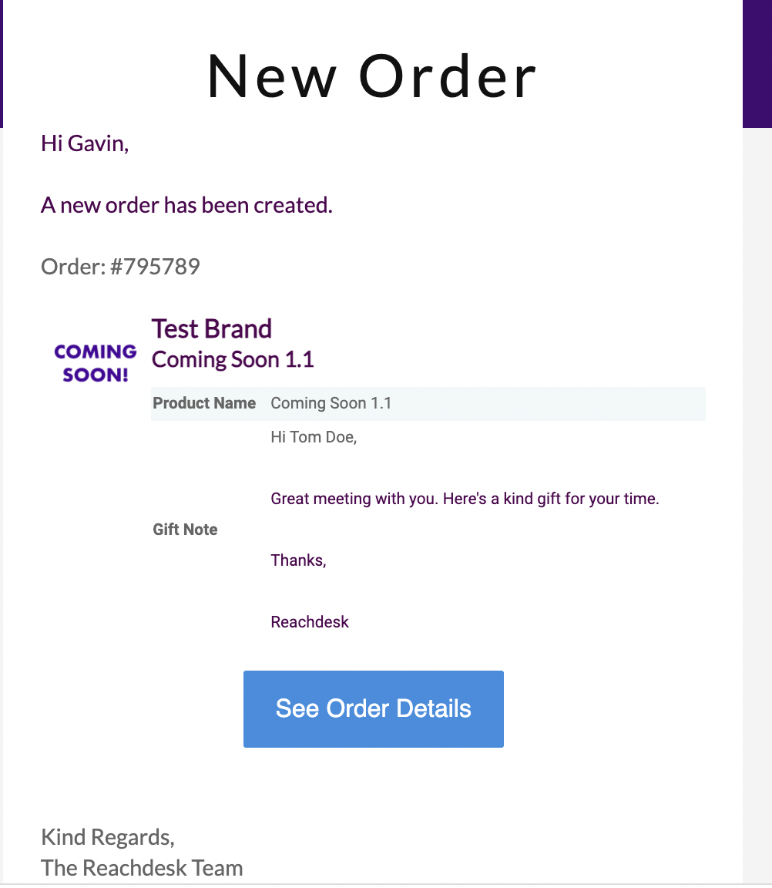
Click Here

2. Login into Fulfilment Platform

You will need to login using your account credential, which would have been sent to you when your account was first setup. If you did not receive this, then please contact marketplace@reachdesk.com who will assist in setting your account up.

You can login directly by using this link. https://app.reachdesk.com/vendor/sign_in

3. Fulfilment Platform

Once you logged into the fulfilment platform you will be able to see all the new and old orders that have come through.

All new orders will be listed under ‘Marketplace orders’.

All orders that have been worked on previously but not completed (i.e no tracking info provided), will show under ‘Current work’.

To begin working on new orders select the orders you wish to work on by checking the box to the left of the order. You can select all orders by clicking the order tab in the top left or you can click on individual orders.
Once you have selected the orders you are going to work on press ‘Begin working on selected orders’

These orders will now show up under ‘current work’.

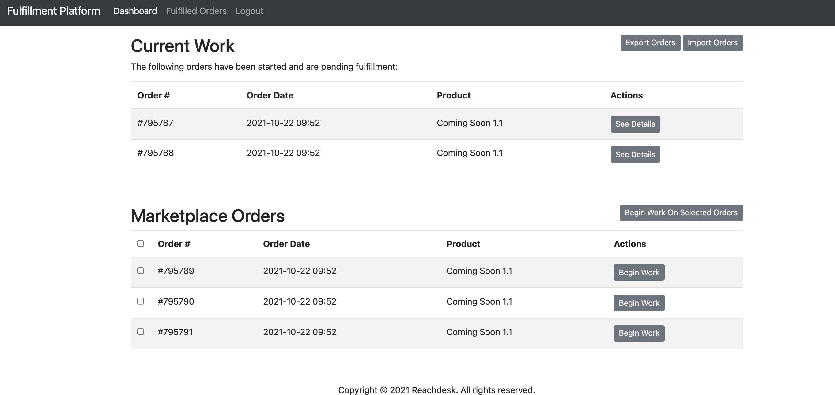
- Click Here to begin working on the order.
- Click Here to select the order to work on

4. Processing Orders

You can now complete these orders either in bulk or individually.

To process the orders individually click the ‘see detail’, located to the right of each order.

Processing orders singularly.

- Click ‘See Details’
- Enter your order reference number
- Select courier
- Enter tracking
- Complete order

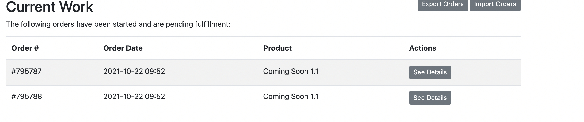
Click Here
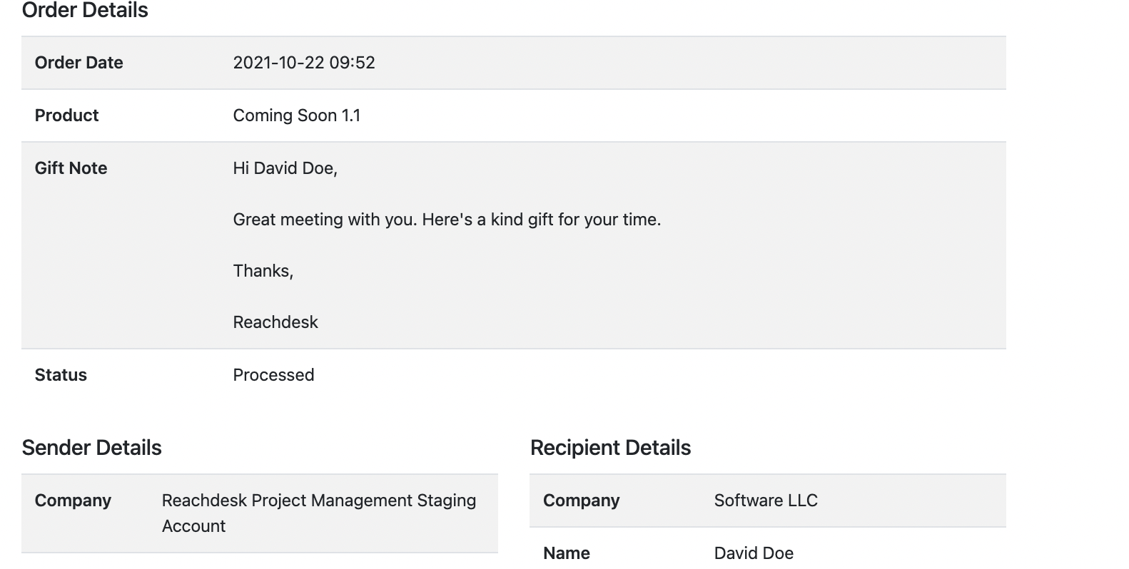

To the bottom of the page, you will see the ‘Fulfilment Details’ box.

Firstly, you can input the ‘vendor order number’. This is a number used for your own reference. It can be left blank if this is not required.

Next you select the courier from a dropdown list. This list contains all couriers that are integrated on our system, meaning we can auto track the status of the shipment and get an automated updated when it is delivered. If you do not see you the courier you are using on this list, please leave it blank.

Finally, you can enter the tracking number here.

Once this is all completed click ‘Finish order’
- Enter a vendor order number for your reference
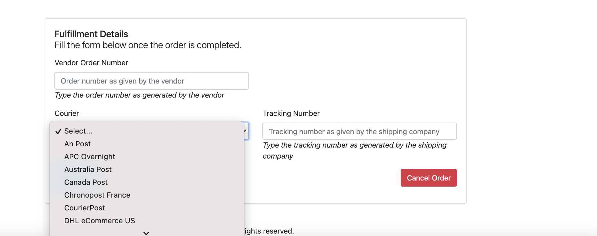
- Select a courier from the list. If your courier does not appear please leave this blank.
- Enter tracking number

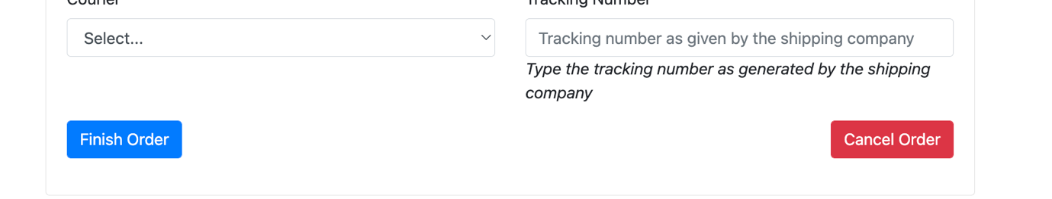
- Click ‘Finish Order’
Processing orders in Bulk.

To complete the orders in bulk.

- Export the csv file
- Input Courier and Tracking information (Please see courier codes table for codes )
- Import the csv file back
- All order will now be under the fulfilled orders Tab
- All orders with integrated couriers will be marked as Delivered automatically
- If we are not integrated with your courier then theis will have to be maunaull ‘Marked as deliver’

Click ‘Export Orders’ to download the csv File

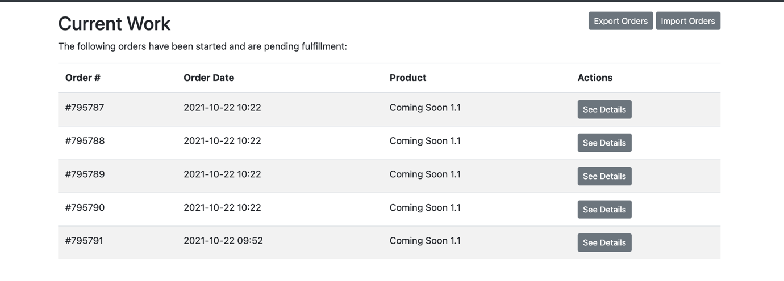
- Change the fulfilled column to Yes , insert the Courier and the tracking number.
- Input tracking code
- Input the tracking number

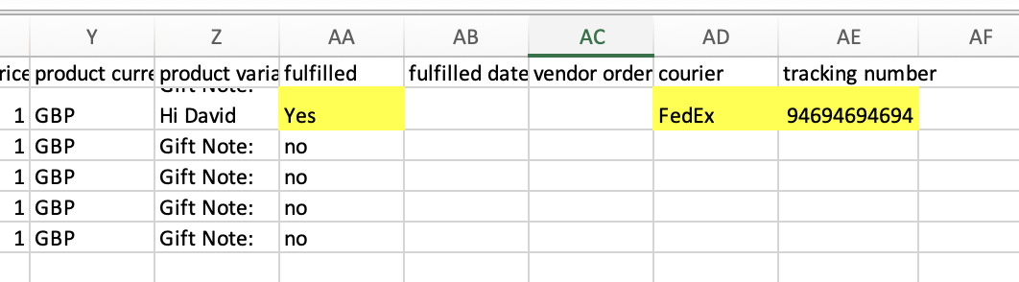

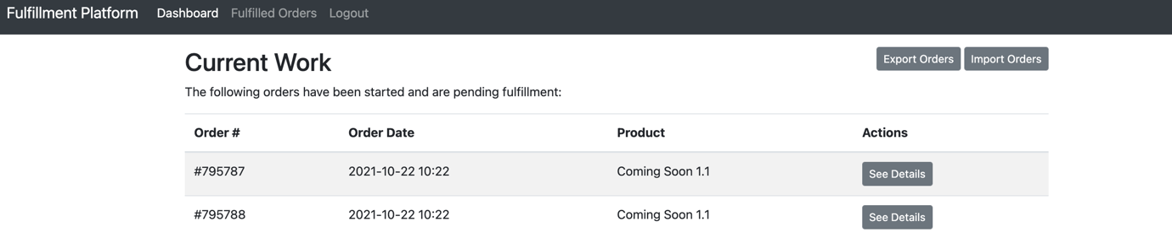

Click the Fulfilled orders Tab to see all shipped orders
- Click on Import orders and select the csv to upload
- Orders will automatically change from shipped to deliver if integrated with our courier.
- If your Courier is not integrated this step will have to be done manually.

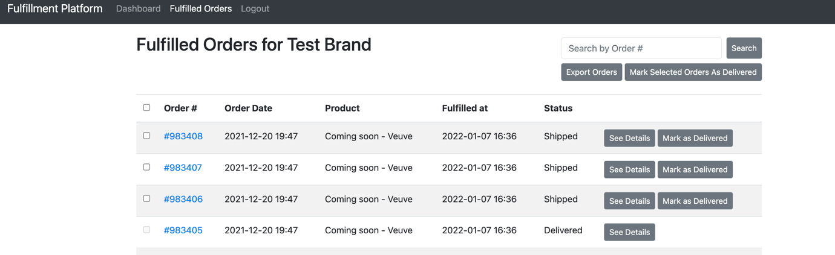

5. Non-integrated Couriers

National courier
If the courier you use is not on the list please leave the courier filed blank and proceed with the next steps. The orders will have to be marked as delivered manually.

You can request for a courier to be added by email Marketplace@reachdesk.com
Please note we are unable to integrate with Royal Mail at this time

Local/Internal Courier
If you use a local or your own service please leave the courier filed blank and proceed with the next steps. The orders will have to be marked as delivered manually.

6. Courier Codes

Courier Name | Courier Code
An Post: | an-post
APC Overnight: | apc-overnight-connum
Australia Post: | australia-post
Canada Post: | canada-post
Chronopost France: | chronopost-france
CourierPost: | courierpost
DHL eCommerce US: | dhl-global-mail
DHL Express: | dhl
DHL Parcel UK: | dhlparcel-uk
DPD: | dpd
DPD Germany: | dpd-de
DPD France: | dpd-fr-reference
DPD UK: | dpd-uk
DX: | dx-b2b-connum
DPD France (formerly exapaq): | exapaq
Aramex Australia: | fastway-au
Fastway New Zealand | fastway-nz
FedEx: | fedex
GLS: | gls
Hermesworld: | hermes
Ivoy: | ivoy-webhook
JNE: | jne
MyHermes UK | myhermes-uk
New Zealand Post | new-zealand-post
Parcel Force | parcel-force
Parcel2Go: | parcel2go
PostNL International: | postnl-international
PostNL Domestic: | postnl
UPS: | ups
USPS: | usps

